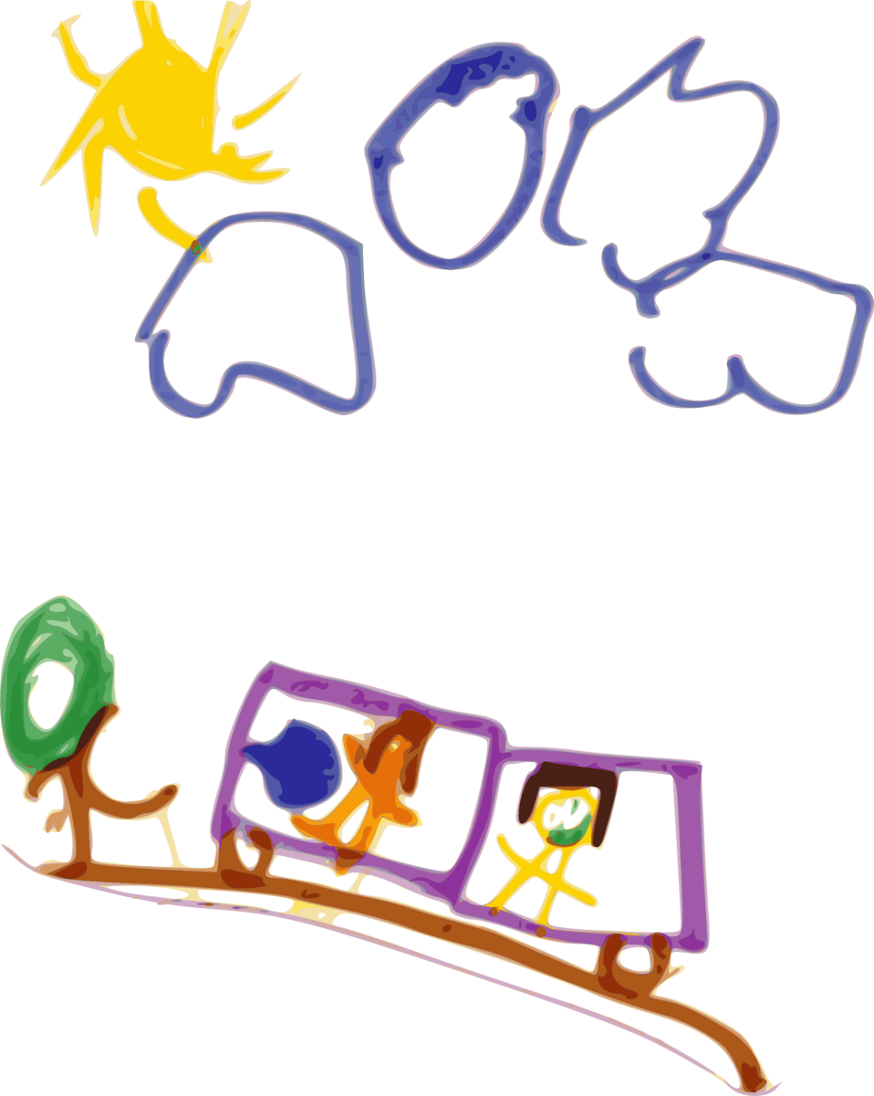
Shaler Area Preschool

The Family and Consumer Science Department of Shaler Area High School oﬀers a Laboratory preschool program for tenth, eleventh and twel h grade. Students enro ing in the Preschool Labs must have ﬁrst taken and passed the Child Development Curriculum. This course familiarizes them with theories and ski s in the area of childcare. The
students learn to work with children under the direction of a qualiﬁed instructor educated in the ﬁeld of Early Childhood Education.

The Preschool laboratory is planned to beneﬁt both the preschool child and the high school student. The preschool child wi beneﬁt as a participant in a carefu y planned educational program. The high school student wi beneﬁt by observing and working with sma children.

The program is open to a children in the Shaler Area School District between the ages of three and ﬁve years. The child must be three years old by September 1st and must be
po y trained. Registration is held each spring for the next school year. Registration cost is $100 per semester or $180 for the entire year, if paid in fu .

The preschool is in session Wednesdays, Thursdays and Fridays from 8:15-10:30. The other days of the week are when the high school students prepare and analyze laboratory experiences. The preschool wi be held in room 104, the Family and Consumer Science wing. It wi be in session for approximately 13-14 weeks each semester. Vacations, holidays, and snow days of the school district wi be observed by the preschool.

Preschool students wi be included in activities such as: The Pledge of A egiance, calendar, weather, stories, puppets, music and movement, art activities, sma muscle manipulation, dramatic play, household activities, sand and water experiences, and large muscle ski s. Each week, the high school students wi choose and develop a particular concept, which wi be the theme and inﬂuence the preschool activities.

Approximately three weeks prior to the beginning of preschool. Le ers are sent to inform of the orientation date and also the date of the ﬁrstday of school. Please contact Mrs. Tara We s at 412-492-1200 ext. 1104 with any questions!

