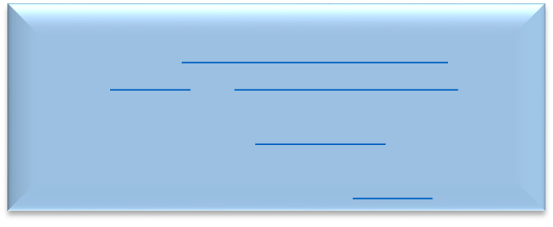
COVID-19 Quarantine Guidance Flowchart K-12 schools
another 5 and
Do you have
Do you have
NO
a mask around
YES
Isolate if
LESS THAN
3 FT.
OR
available.
ꝉ
BETWEEN
3-6 FT.
wearing
masks
correctly?
NO
Quarantine
for 5 days,
mask
for another 5
and seek
symptoms?
NO
You are
excluded from
quarantine and
testing.
stay home
until 24 hours
have passed
since
NO
If you were
infected
person and
both masked,
no action is
needed. If
closer or
tested 5 days
after
exposure.

Close Contact
Are you staff or a student?

STAFF
Are you vaccinated*?
STUDENT Are you vaccinated*?

NO YES NO YES
Quarantine for What was the distance
5 days, mask for symptoms? between you and the symptoms? seek testing. positive student case?
OR Participate in
TTS program if
available.ꝉ Get tested between 3-6
and stay Quarantine Were both ft. of an
home until for 5 days, students
Get tested 5 days symptoms mask for
after exposure. You have another 5 and
don’t need to resolved for seek testing. consistently
quarantine but wear 24 hours. Participate in and you were
others. Isolate if test test is TTS program if either was
is positive. positive. unmasked, wear a
* Vaccinated This means You are ages 18 or older and mask and get have received all recommended vaccine doses,
including boosters and additional primary shots for some immunocompromised people. You are ages 5-17 years and completed the primary series of COVID-19 vaccines. You had confirmed COVID-19 within the last
90 days (you tested positive using a viral test).1 YES
ꝉ TTS, or Test-to-Stay, is limited to asymptomatic testing. Do you have unvaccinated or partially vaccinated students and staff
with in-school exposures where exposure occurred during periods of masking. The 1st test should be within 2-4 days after exposure. The 2nd test should be within 5-7 days after exposure. Only available at
participating schools.2 YES
A person is considered a close contact if they were within 6 ft Get tested and of an infectious person for 15 consecutive minutes or more in
an indoor school setting with or without a mask. EXCEPTION: In the K–12 indoor classroom or structured
outdoor setting, the close contact definition excludes students
who were within 3 to 6 feet of an infected student (laboratory- symptoms confirmed or a clinically compatible illness) if both the infected resolved. student and the exposed student(s) correctly and consistently Isolate if test is wore well-fitting masks the entire time.1 positive.

1 https://www.cdc.gov/coronavirus/2019-ncov/your-health/quarantine-isolation.html
2 https://www.alleghenycounty.us/Health-Department/Resources/COVID-19/Information-on-COVID-19-Testing.aspx
Updated 01/03/2022

