Symptoms of Coronavirus (COVID-19)

Know the symptoms of COVID-19, which can include the following:

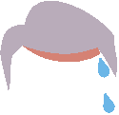
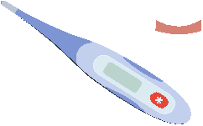
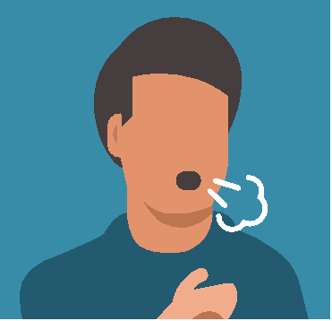
Cough, shortness of breath or dificulty breathing Fever or chills

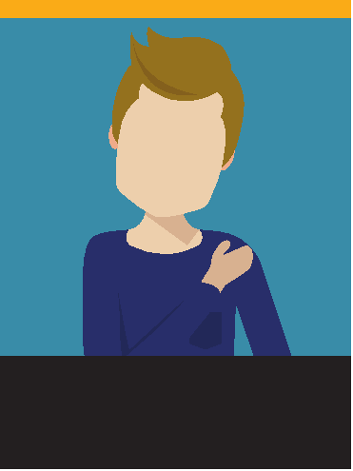
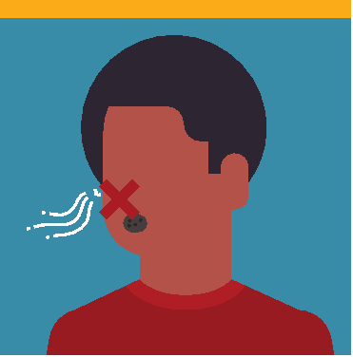
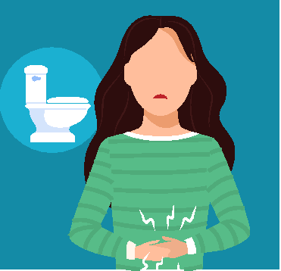
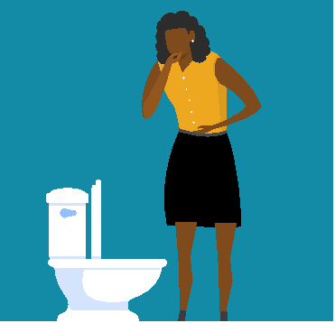
Muscle or body aches Vomiting or diarrhea New loss of taste or smell

Symptoms can range from mild to severe illness, and appear 2-14 days after you are exposed to the virus that causes COVID-19.

Seek medical care immediately if someone has emergency warning signs of COVID-19.
• Trouble breathing • Inability to wake or • Persistent pain or pressure stay awake
in the chest • Bluish lips or face
• New confusion

This list is not all possible symptoms. Please call your healthcare provider for any other symptoms that are severe or concerning to you.

cdc.gov/coronavirus 316475-A 07/21/2020

