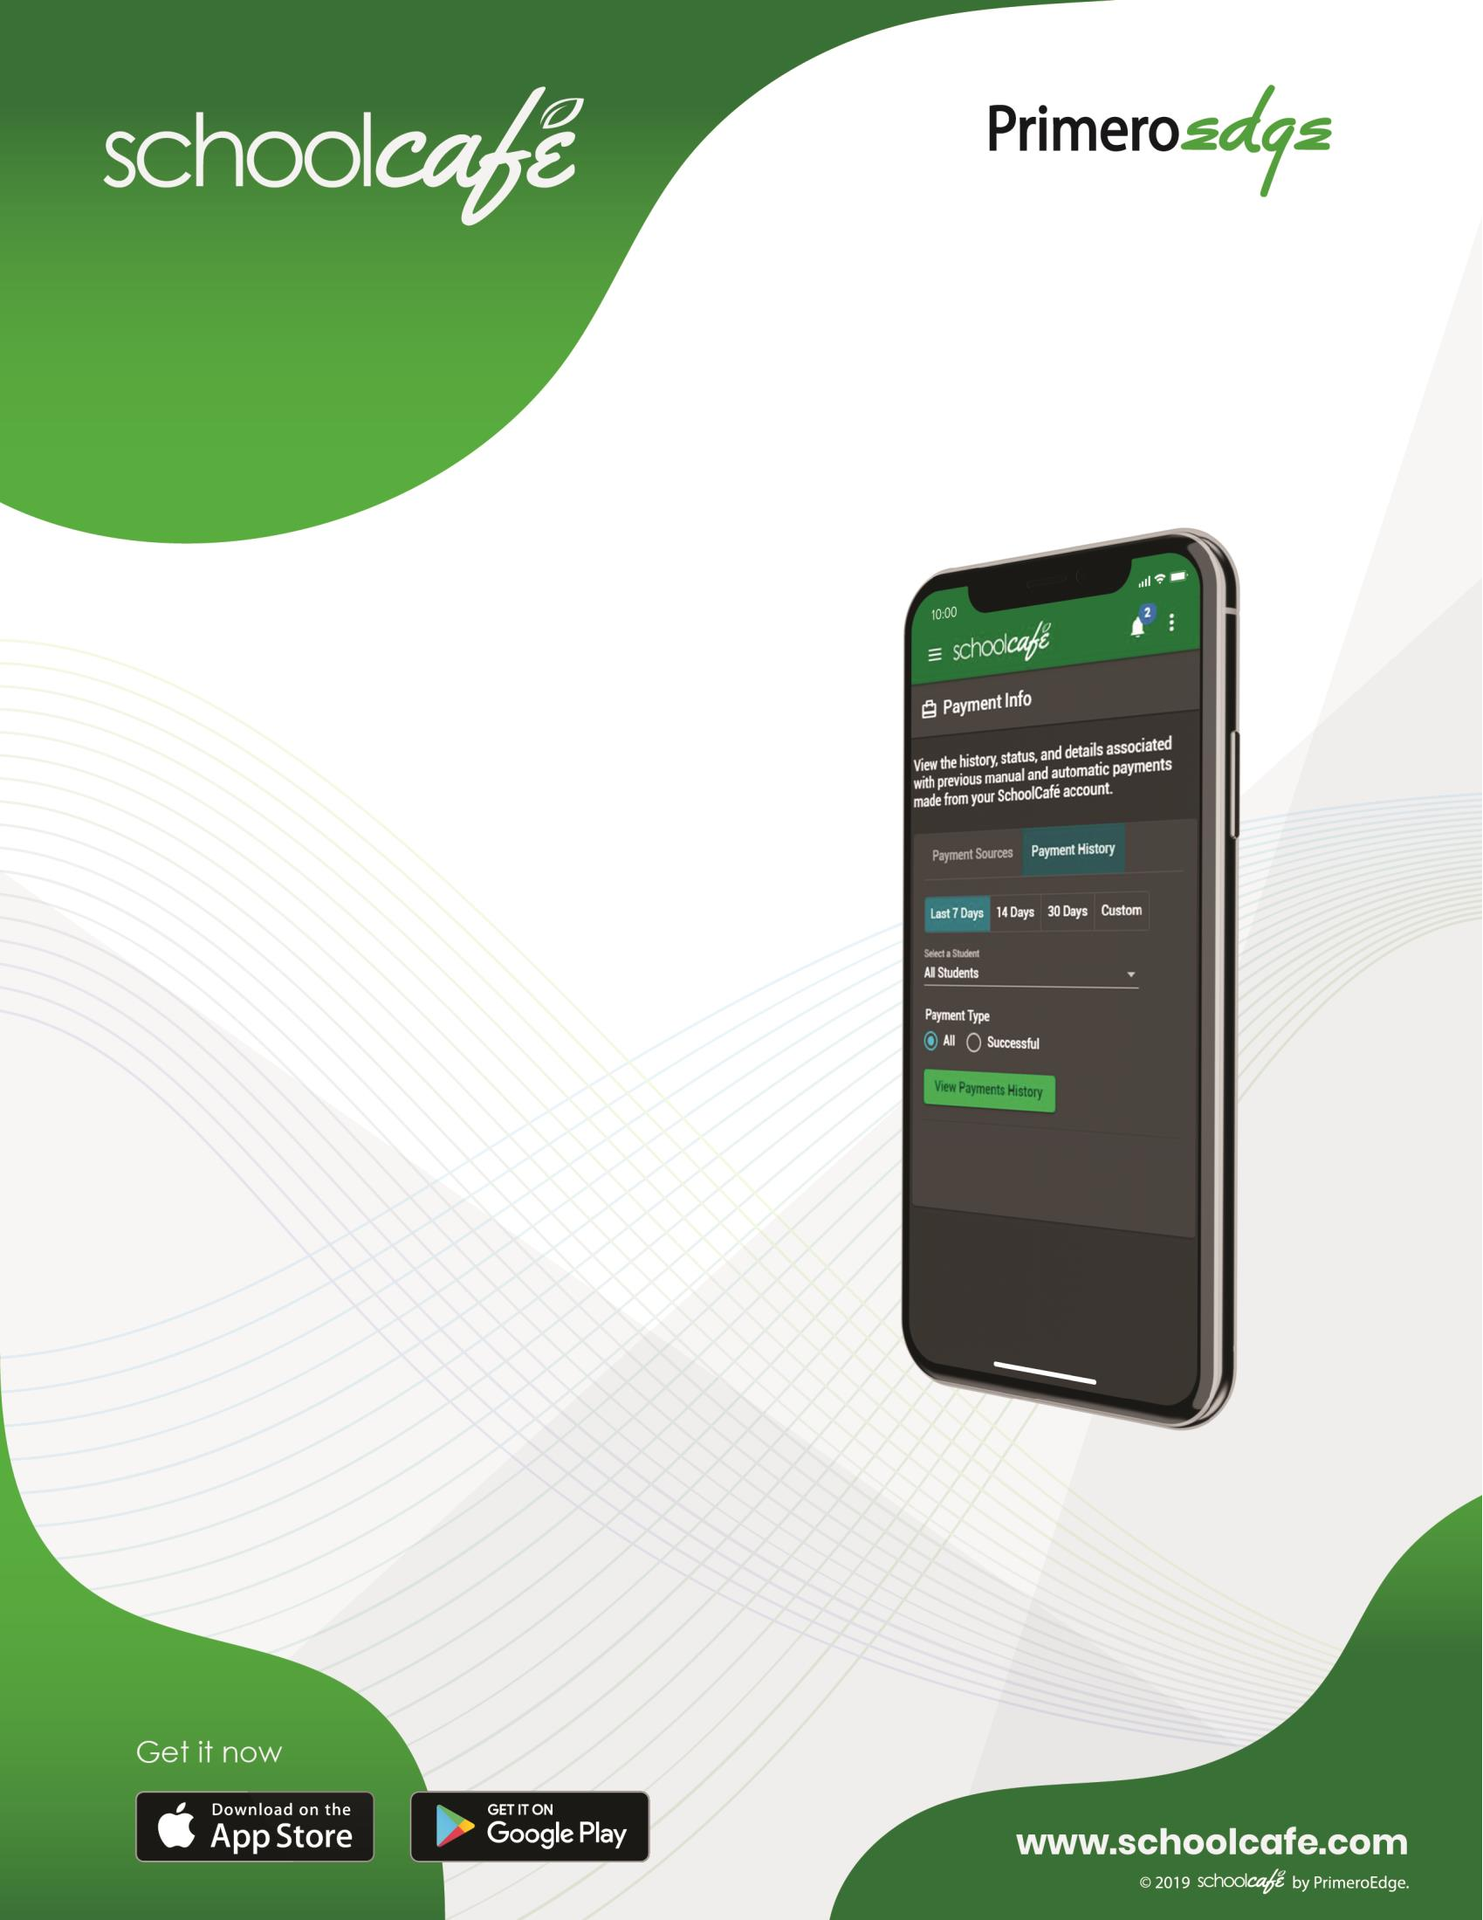
Oneapp foryour entire cafeteria. PAYMENTSMADEEASY
With email and push notifications, parents can
stay on top of their student's account balance. Low balance reminders make sure parents never miss a payment and students always have adequate funds in their account.
FREE&REDUCED APPLICATIONS

Forget paper applications and delays in verification responses. SchoolCafé lets parents apply for Free and Reduced applications online and even respond to verification requests from their phone.

